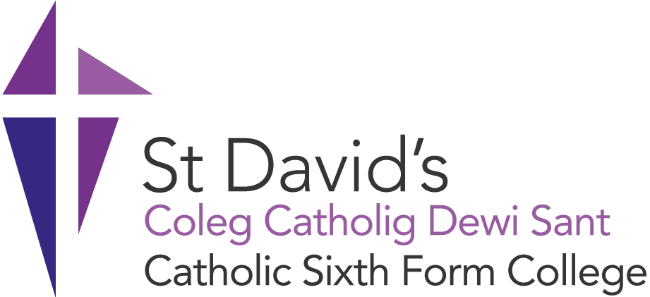

**SCHOLARSHIP APPLICATION FORM FOR 2023/24**

***At St David’s College, we believe that education is about transforming lives and allowing learners to reach their full potential, and we are committed to attracting the most talented and dedicated learners, regardless of their geographic, social or financial background.***

**Guidelines**

* We are offering two types of scholarship for 2023/24 one for academic achievement and one for contribution to the community. **You can only apply for one scholarship**. Applications for the academic achievement scholarship and the contribution to community scholarship should be made using the same application form.
* You will need to send copies/ photographs of your qualifications/ exam results slips with your application form as proof of your qualifications.
* You will need to provide supporting documentation with your application, for example, certificates of attendance and other certificates you may have gained during your time at school.
* Please ensure that your application is clear and legible. **Only applications made electronically will be accepted.**

The deadline for applications is **Monday 28th August 2023**. Candidates may be invited for interview as part of the selection process.

**In 2023, each scholarship will be worth £1250 each year. The contribution to community will be £1000 for student and £250 to their nominated charity.**

Submit your completed application to the address below:   
  
**Mrs L Newman, Vice Principal  
Email: LNewman@stdavidscollege.ac.uk**

Successful candidates, who are awarded a scholarship, will be asked to contribute to promotional activities.

**Personal details**

|  |  |
| --- | --- |
| **Title (Mr/ Miss/ Ms)** |  |
| **Family Name** |  |
| **First Name** |  |
| **Date of Birth** |  |
| **Address** |  |
| **Postcode** |  |
| **Telephone** |  |
| **Email** |  |
| **Nationality** |  |
| **Scholarship Applied for**  **(Academic Achievement Scholarship or Contribution to Community Scholarship)** |  |

**Application details**

**Current Qualifications** (**An example has been provided in the first row below)**

|  |  |  |  |  |
| --- | --- | --- | --- | --- |
| **School** | **Subjects** | **Qualifications (e.g. GCSE, BTEC Level 2)** | **Grade Awarded** | **Date Awarded** |
| **St. Richard Gwyn** | **English Literature** | **GCSE** | **A\*** | **August 2023** |
|  |  |  |  |  |
|  |  |  |  |  |
|  |  |  |  |  |
|  |  |  |  |  |
|  |  |  |  |  |
|  |  |  |  |  |
|  |  |  |  |  |
|  |  |  |  |  |
|  |  |  |  |  |
|  |  |  |  |  |
|  |  |  |  |  |
|  |  |  |  |  |
|  |  |  |  |  |
|  |  |  |  |  |
|  |  |  |  |  |

**Provide a personal statement to support your application for a scholarship (in approximately 500 words). You can make reference to:**

* **Your existing academic achievements and where you have achieved a high standard in your studies**
* **The skills and specialist knowledge that you have gained**
* **The courses that you hope to study whilst at St. David’s and your future career aspirations**
* **Outstanding achievements in the face of adversity and personal achievements**
* **What motivates you**
* **School and community involvement to date**
* **Future plans to contribute to college life and wider community involvement**

|  |
| --- |
|  |

**I confirm that the above information is true and that if I have made a false declaration I may be liable to legal action by Saint David’s Catholic Sixth Form College.**

Student signature: Date: