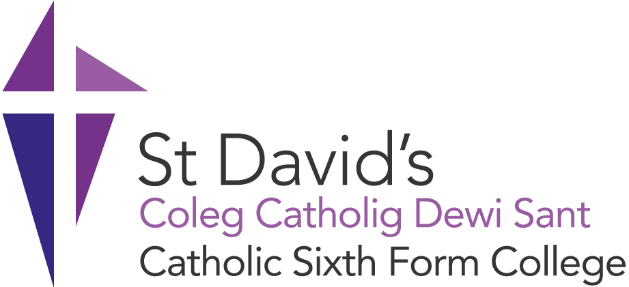

|  |  |  |  |  |  |  |
| --- | --- | --- | --- | --- | --- | --- |
| **Complaints, Concerns and Compliments Policy**   |  |  | | --- | --- | | Version No. | 4 | | Approval date: | 2/3/17 | | Next review date: | 1/9/26 | |
|  |

Table of Contents

1. Introduction 2

2. How the College Defines a Complaint or Concern 3

3. What You Can Complain or voice a Concern about 3

4. The Complaints and Concerns Process 3

4.1 Stage 1 - Front Line Resolution 3

4.2 Stage 2 - Raising an informal complaint or concern 3

4.3 Stage 3 - Formal Complaint 4

4.4 Stage 4 - Appeals 4

5. The Compliments Process 5

6. Learning from Complaints 5

7. Malicious Complaints 5

8. Getting help to make your complaint 6

9. APPENDIX 6

# Introduction

St David’s Catholic College is committed to providing a high quality and successful learning experience for all.

Receiving feedback and compliments is always welcomed by the College and supports our pursuit of continuous improvement

The College aims to be fair and open when dealing with any concerns or complaints. We will give full and careful consideration to all concerns and complaints and deal with them as swiftly as possible, whilst striving to resolve any complaint through dialogue and mutual understanding.

**Our Commitment to You**

* We will ensure that raising a concern or making a formal complaint is as easy as possible.
* We will treat all concerns and complaints seriously.
* Any complaint will be dealt with honestly, politely and in confidence.
* We will deal with the concern or complaint promptly, thoroughly and impartially.
* We will keep you up to date with the progress at each stage.
* We will tell you what actions will be taken to put things right.
* All complaints will be recorded on a complaints log and will be reported to the senior leadership team and governing body on a regular basis.
* We will learn from concerns raised and complaints made and use them to improve our service.
* Whilst we will handle all complaints discreetly, if a complaint is made about a member of staff, we will need to share the concerns with them as part of the investigation, and invite their view of what happened.

.

# How the College Defines a Complaint or Concern

The College define a complaint or concern as:

‘An expression of dissatisfaction by one or more learners or stakeholders on their behalf, about the College’s action or lack of action, or about the standard of service provided by the College’.

# What You Can Complain or voice a Concern about

You can make a complaint or raise a concern about any aspect of our services including teaching and training, support and services, advice and guidance and College facilities. You can also complain or raise a concern if you feel you have been treated unfairly or inappropriately. See appendix for the types of things you can complaint or raise concerns about and those that aren’t covered by this policy.

# The Complaints and Concerns Process

## 4.1 Stage 1 - Front Line Resolution

We aim to resolve concerns and complaints quickly and close to where we provided the service. This could mean an on-the-spot apology and explanation if something has clearly gone wrong and immediate action to resolve the problem. This is where issues are straightforward and easily resolved; requiring little or no investigation and we will endeavour to sort out your concerns promptly.

The best way to deal with these is usually straight away with the staff directly concerned; so if possible, please talk to the member of staff involved as they may be able to sort things out for you immediately. Concerns about courses can be dealt with the relevant Learning Area Manager or if you are unsure who to speak to, contact a Personal Tutor who will be able to advise you.

## 4.2 Stage 2 - Raising an informal complaint or concern

If your concern or complaint has not been resolved at Stage 1, or you feel the resolution is not satisfactory, please complete [Stage 2- Feedback Form](https://forms.office.com/Pages/ResponsePage.aspx?id=tdq5IuWLekmShsmO_cXcw5eYden-4HNBnEw4cVPSVPZUQjQ4VTlZOEoyQzRaTTU5VllCMlcyWk9ZMC4u). The complaint form will also be logged on the complaints database.

Once the complaint has been logged, the relevant manager will review the content and determine whether the matter that is being raised would be more appropriately dealt with under another College Policy or Process, such as Safeguarding or Misconduct. If a different procedure is to be used to resolve your concerns, you will notified with an explanation of the process which will be followed.

The relevant manager will investigate the issue thoroughly and fairly and will respond in writing to the complainant within 10 working days of receiving the complaint (excluding the Christmas, Easter and summer holiday shutdown period). The complainant may be invited to meet with the manager to discuss the matter more fully if required. Once a course of action is decided then the complainant will be informed of this in writing, along with a notification of the right to appeal.

The manager dealing with your concern at this stage of the procedure will have the authority and discretion to consider any reasonable options to resolve your concerns. It is therefore envisaged that the majority of complaints will be resolved satisfactorily at this stage with no further action being necessary.

## 4.3 Stage 3 - Formal Complaint

If you feel that your concern or complaint has not been satisfactorily resolved at Stage 2, you may request that the matter is dealt with as a formal complaint. You should submit your request in writing to Claire Kelly, Personal Assistant, St David’s Catholic College, Ty Gwyn Road, Penylan, Cardiff CF23 5QD or email to [ckelly@stdavidscollege.ac.uk](mailto:ckelly@stdavidscollege.ac.uk)

On receipt of the formal complaint, an independent senior manager will be appointed to undertake a formal investigation of the facts relating to your complaint. You will receive acknowledgement of your complaint and be provided with the name and contact details of the Investigating Manager within 5 working days (excluding the Christmas, Easter and summer holiday shutdown period).

The Investigating Manager may contact you for further information and may ask to meet with you to discuss details of the complaint further.

The Investigating Manager will normally provide you with a formal written response within 10 working days from the acknowledgement. If for any reason, there will be a delay, we will let you know.

## 4.4 Stage 4 - Appeals

If the complainant (learner or parent) is not satisfied with the response received to a complaint or the outcome of the complaint, the complainant can appeal to the Principal in writing.

Please note, the right to appeal may only be considered if there is new evidence which was not made available at an earlier stage or where the complainant feels that the investigation was not carried out fairly or thoroughly, and/or the findings were not borne out by the evidence.

The address is:

Mr Geraint Williams

Principal

St David’s Catholic College

Ty Gwyn Road

Penylan

Cardiff

CF23 5QD

The appeals process will be determined by the circumstances; this could include:

* Paper based review of the process
* Meeting with the complainant
* Consideration of new evidence
* Alternative means of resolution.

We will normally write to you within 10 working days (excluding the Christmas, Easter and summer holiday shutdown period) with the outcome of your appeal. If we cannot provide an outcome within this agreed timescale we will write to let you know. This represents the final stage of the College’s Complaints, Concerns and Compliments Policy.

In cases where the matter concerns the conduct of the Principal, or a member of the governing body, the Chair of Governors will arrange for the matter to be investigated.

# The Compliments Process

If you would like to convey a compliment, please complete our [Compliments Form](https://forms.office.com/Pages/ResponsePage.aspx?id=tdq5IuWLekmShsmO_cXcw1LhSpe6w-dHhnIohEcvBFtUNVpGRzYwWkZNR042RTBKNFJRVEkxRUhVSSQlQCNjPTEu). Compliments are sent to those praised within them.

### Learning from Complaints

The College will;

* Use complaints data to identify the cause of complaints
* Take action to reduce the risk of recurrence
* Record the details of outcomes and corrective action in the complaints database
* Survey users to determine the fitness for purpose of the complaint’s policy. This is administered 6 weeks after the closure of the complaint.
* Annually review the complaints policy to ensure improved service delivery.

### Malicious Complaints

Where the College has investigated a complaint and the outcome is that the complaint is malicious, the College reserves the right to consider whether to bring action against the complainant if false statements and/or allegations have been made.

Where it is likely that a learner of the College has made false statements and/or allegations against the College or its members of staff, then the matter may be further pursued under the Studentship Policy.

### Getting help to make your complaint

We understand that you may be unable, or reluctant, to make a complaint yourself. We accept complaints from the representative of a person who is dissatisfied with our service. We can take complaints from a friend or relative, if you have given them your consent to complain for you.

We are committed to making our services easy to use for everyone. In line with our statutory equalities duties, we will always ensure we make reasonable adjustments to help customers access and use our services. If you have trouble putting your complaint in writing, or want this information in another language or format, please contact Dr R Jones – [rjones@stdavidscollege.ac.uk](mailto:rjones@stdavidscollege.ac.uk)

### APPENDIX

What can I complain about?

You can complain about things like:

* A failure to provide a service, or an inadequate quality or standard of service
* The admissions process
* The disciplinary process
* A request for a service or for information, which we have not actioned or answered
* Our policies
* Wrong information about academic programmes or our services
* The quality and availability of facilities and learning resources
* Accessibility of our buildings or services
* The behaviour of a learner, member of staff or contractor
* Treatment by or attitude of a member of staff or contractor
* Disagreement with a decision where you cannot use another procedure, e.g. appeal
* Our failure to follow the proper administrative process

Your complaint may involve more than one college service or be about someone working on our behalf, such as a contractor.

What can’t I complain about?

There are some things we can’t deal with through our complaints handling procedure. These include:

* A routine first-time request for a service
* A request for information or an explanation of policy or practice
* A disagreement with academic judgement
* A claim for compensation against the college
* Issues that are in a court of law or have already been heard by a court or tribunal
* Disagreement with a decision where a right of appeal exists
* A request for information under the Data Protection or Freedom of Information Act
* A grievance by a member of staff
* An attempt to have the college open up or reconsider a complaint we have concluded or given our final decision on.

If other procedures or rights of appeal can help you resolve your concerns, we will give information and advice to help.